Database Management, 2019 Midterm 1

Q1. (6%) Explain the **entity integrity constraint, foreign key** and the **referential integrity constraint**.

Q2.

(a) (4%) Give an example to explain the differences between a key and a superkey.

(b) (4%) When a NULL is involved in a comparison operation, the result is considered to be UNKNOWN. Show the results of the following logical expression respectively: (i) FALSE OR（TRUE OR UNKNOWN）; (ii) UNKNOWN AND UNKNOWN; (iii) (TRUE AND UNKNOWN) OR UNKNOWN; (iv) (FALSE AND UNKNOWN) OR (TRUE OR UNKNOWN).

Q3. (5%) Describe three possible options to handle the **Delete** operation when a constraint is violated. Please use diagrams (examples) to aid your explanations.

Q4. Aggregate functions can be applied to a particular column (attribute), that is, a collection of values.

(a) (2%) Explain how the NULL values are handled when the AVG function is applied to the attribute Salary in the Employee table.

(b) (2%) If the collection becomes empty because all values are NULL, what will the COUNT function return?

(c) (4%) Explain how will the COUNT(*) handle the tuple (of the query result) that contain NULL values of some attributes in the tuple? Explain the differences between COUNT(Salary) and COUNT(Distinct Salary).

Q5. Below are three tables for “2019 Best Singer Battle!!” in NCTU:

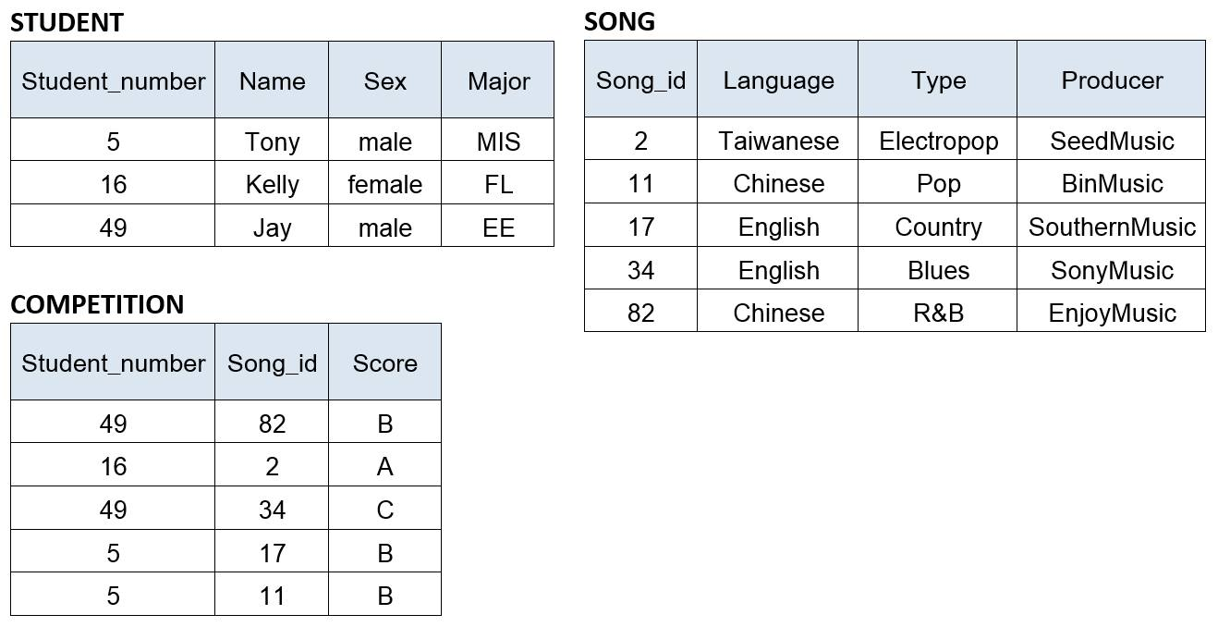

Write SQL update statement to do the following on the database schema shown in above Figure.

a. (4%) Update all the Competition Scores of the songs, in which Type is ’Pop’ and is sang by ‘Tony’ to ‘A’.

b. (3%) Insert a new student, <13,’Alice’,’female’,’IMF’>

c. (3%) Delete records from the Song table, in which Producer is ‘BinMusic’ and Type is ‘R&B’.

d. (5%) Write a SQL query to list the names of all male students who have at least two scores of ‘B’ for singing songs produced by ‘SonyMusic’ in the competitions.

Q6. Below is a subset of relations from COMPANY schema. The keys have been underlined.

**EMPLOYEE** (FNAME, LNAME, SSN, BDATE, ADDRESS, SEX, SALARY, SUPERSSN, DNO)

**DEPARTMENT** (DNAME, DNUMBER, MGRSSN, MGRSTARTDATE)

**PROJECT** (PNAME, PNUMBER, PLOCATION, DNUM)

**WORKS_ON** (ESSN, PNO, HOURS)

**DEPENDENT** (ESSN, DEPENDENT_NAME, SEX, BDATE, RELATIONSHIP)

Express the following Queries in SQL statements.

1. (6%) Query 1: For each employee who works on the project controlled by the Research department, list the name of the employee and the names of the projects that he/she works on.
2. (6%) Query 2: For each employee who has more than two dependents, retrieve the name, the salary, and the department name of the employee.
3. (6%) Query 3: For each department with more than five employees, list the department name, the sum of salaries and the total number of employees of the department.
4. (6%) Query 4: For each employee who works on the “Mountain Travel” project and whose salary is greater than the salary of his/her supervisor, list the name of employee and the name of his/her supervisor.
5. (6%) Query 5: For each project located in “Hsinchu” and with more than ten employees working on, retrieve the project number, the project name, and the number of Male employees who work on the project.
6. (6%) Query 6: For each employee who has no dependents and does not work on any project, list the name of the employee and the name of his/her manager. (hint: NOT EXISTS)
7. (6%) Query 7: For each employee who has no dependents and whose number of working projects is greater than the number of working projects of every employee in department number 5, list the name of the employee and the name of his/her department.
8. (6%) Query 8: Retrieve the name and salary of each employee who is the manager of the “R&D” department and is the direct supervisor of at least five employees.
9. (a) (6%) Query 9: Retrieve the name of each employee who works on all the projects on which the employee John Smith works.

(b) (4%) Assume that JSmithPNOs denotes the set of projects on which the employee John Smith works; and EmpPNOs denotes the set of projects on which an employee works. Draw the set diagrams to show four possible set relations between JSmithPNOs and EmpPNOS, and explain why NOT_EXISTS and EXCEPT can be used to correctly implement the set relation that EmpPNOS contains JSmithPNOS.

1. (8%) For each employee who works for the AI project and has more than two supervisors (direct and indirect supervisors), list the name of the employee and the names of all his/her supervisees at all levels (direct and indirect supervisees).